**Spring Core and Maven**

**Exercise 1:** **Configuring a Basic Spring Application**

**Code:**

<bean id="bookRepository" class="com.springboot.LibraryManagement.repository.BookRepository" />  
<bean id="bookService" class="com.springboot.LibraryManagement.service.BookService"> </bean>

package com.springboot.LibraryManagement.repository;

@Repository  
public class BookRepository {  
 public BookRepository(){  
 System.*out*.println("In the Book Repository class");  
 }  
}

package com.springboot.LibraryManagement.service;

@Service  
public class BookService {  
 public BookService(){  
 System.*out*.println("In the Book service class");  
 }  
}

@SpringBootApplication  
public class LibraryManagementApplication {  
  
 public static void main(String[] args) {  
 BookService bookService = new BookService();  
 BookRepository bookRepository = new BookRepository();  
 }  
  
}

**Output:**

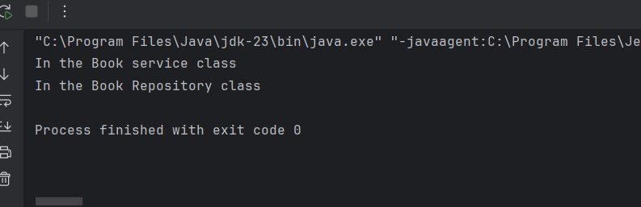

**Exercise 2: Implementing Dependency Injection**

**Code:**

<bean id="bookRepository" class="com.springboot.LibraryManagement.repository.BookRepository" />  
<bean id="bookService" class="com.springboot.LibraryManagement.service.BookService">  
 <property name="bookRepository" ref="bookRepository" />  
</bean>

package com.springboot.LibraryManagement.repository;  
  
public class BookRepository {  
  
 public String bookName(){  
 return "Atomic Habits";  
 }  
}

package com.springboot.LibraryManagement.service;  
  
import com.springboot.LibraryManagement.repository.BookRepository;  
  
public class BookService {  
  
 private BookRepository bookRepository;  
  
 public void setBookRepository(BookRepository bookRepository) {  
 this.bookRepository = bookRepository;  
 }  
  
 public void getBook(){  
 String book = bookRepository.bookName();  
 System.*out*.println("Book found: "+book);  
 }  
}

@SpringBootApplication  
public class LibraryManagementApplication {  
  
 public static void main(String[] args) {  
  
 ApplicationContext context = new ClassPathXmlApplicationContext("applicationContext.xml");  
 BookService b = context.getBean("bookService", BookService.class);  
 b.getBook();  
 }  
  
}

**Output:**

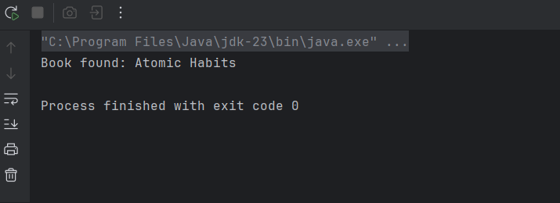

**Exercise 4: Creating and Configuring a Maven Project**

**Code:**

<dependencies>  
 <!-- Spring Core (includes context & beans) -->  
 <dependency>  
 <groupId>org.springframework</groupId>  
 <artifactId>spring-context</artifactId>  
 <version>5.3.34</version>  
 </dependency>  
  
 <!-- Spring AOP -->  
 <dependency>  
 <groupId>org.springframework</groupId>  
 <artifactId>spring-aop</artifactId>  
 <version>5.3.34</version>  
 </dependency>  
  
 <!-- Spring Web MVC -->  
 <dependency>  
 <groupId>org.springframework</groupId>  
 <artifactId>spring-webmvc</artifactId>  
 <version>5.3.34</version>  
 </dependency>  
  
 <!-- Servlet API (needed for Web MVC) -->  
 <dependency>  
 <groupId>javax.servlet</groupId>  
 <artifactId>javax.servlet-api</artifactId>  
 <version>4.0.1</version>  
 <scope>provided</scope>  
 </dependency>  
</dependencies>

public class LibraryManagementApplication {  
 public static void main(String[] args) {  
 System.*out*.println("System configured Successfully!");  
 }  
}

**Output:**

